**Department of Science and Humanities**

F Y B Tech SEM I 2021-22

Engineering Physics Lab Course

**Numerical Aperture**

Name : Hardik Shah

Roll No. : 16010221025

Batch : D2

Branch : ETRX

**Aim:** To find the numerical aperture of a given optic fibre and hence to find its acceptance angle.

**Apparatus:** Emitter, concentrator, fiber, fiber stand, detector, output unit

**Diagram:**

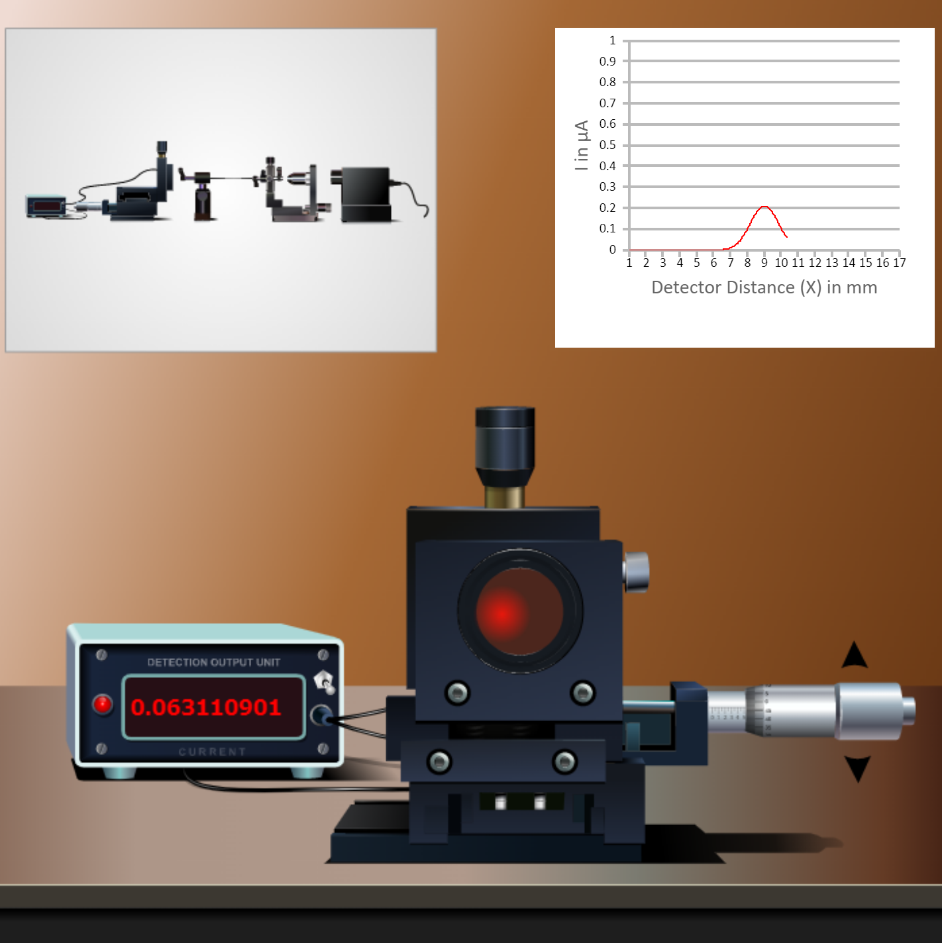

**Observation Table:**

|  |  |  |  |  |  |  |
| --- | --- | --- | --- | --- | --- | --- |
| Obs. No. | d(mm) | I max(µA) | $\frac{I_{max}}{2.71}$ (µA) | 2r (mm)  = ${(x}_{max}-x_{min})$ | r (mm) | NA |
| 1 | 2mm | 0.3694 | 0.1363 | 1.4mm | 0.7mm | 76.94 |
| 2 | 3mm | 0.2457 | 0.0906 | 2.0mm | 1.0mm | 18.42 |
| 3 | 4mm | 0.1847 | 0.0681 | 2.8mm | 1.4mm | 19.32 |
| 4 | 5mm | 0.1477 | 0.0545 | 3.4mm | 1.7mm | 18.78 |
| 5 | 6mm | 0.1231 | 0.0454 | 3.1mm | 1.55mm | 14.47 |
| 6 | 7mm | 0.1055 | 0.0389 | 5.2mm | 4.6mm | 33.30 |

Formula:

Numerical Aperture (NA) = $\frac{r}{\sqrt{r^{2}+d^{2}}}$

Acceptance angle (i) = Sin-1 (NA) =

Home Assignment:

* Determine Numerical Aperture and Acceptance angle

The “Numerical Aperture” (NA) is the most important number associated with the light gathering ability of an objective or condenser. It is directly related to the angle of the cone which is formed between a point on the specimen and the front lens of the objective or condenser, determined by the equation NA = n sin ∝.